MICROSOFT TEAMS

Download and access Microsoft Teams

- Download Microsoft Teams on your computer or smartphone before the training session
https://www.microsoft.com/en-za/microsoft-365/microsoft-teams/download-app
- Learn more about Office 365: https://www.unisa.ac.za/sites/myunisa/default/Important-Links/Microsoft-Office-365. Once installed correctly, a Microsoft Teams icon will appear on your desktop. Please contact bugmaster@unisa.ac.za if you encounter any technical issues.
- Double-click on the Microsoft Teams icon on your desktop and sign in with your myLife e-mail address and myUnisa password
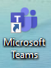

Join an online training session

- Please join the meeting at least 10 minutes before the training session is scheduled to start to ensure that you are connected and ready for the session. Please note that once the session starts, no access problems will be attended to.
- Click on Join Microsoft Teams Meeting. This will appear in your e-mail invitation or in your appointment on your calendar.
- Microsoft Teams will open and ask you to join

- . Make sure that the camera and microphone are both disabled. Click on the blue ‘Join now’ button to join the online training session.
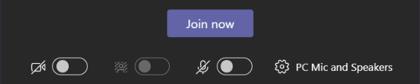
- Once connected, you will see a toolbar at the bottom of your screen. Move your mouse across the screen to make it appear if you don’t see it.
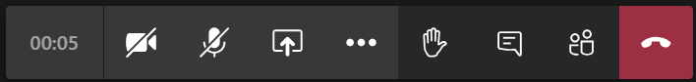
- Make sure your microphone is muted and that your video is disabled immediately after joining an online training session, to ensure that you save your data as much as possible and that your background noise doesn’t interfere with the training session.
- Check your device settings by clicking on 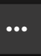 and then selecting device settings. Make sure that your volume control is on high so that you can hear everything the librarian presenter says.
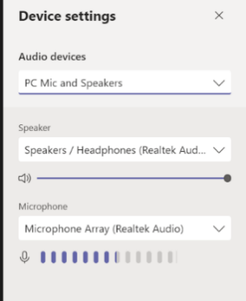

- Click on to see the Chat session. You are welcome to type questions or comments here. Please note that some of the questions might only be answered after the training session. The whole ‘chat’ for the training session will be available on Microsoft Teams under the Chat icon. This is also where the video recording of the session will display.
- Please avoid clicking on 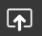 during group training sessions. This icon is used to share a screen, and by clicking on it, it will cause the librarian presenter’s screen to disconnect.
- There will be time to ask questions live during the training session. Make use of the icon to indicate that you want to ask a question. Remember to click on again after asking your question, otherwise the hand icon will remain active
- Click on  when the training session is finished. This will take you out of the meeting.
- The video recording will take a while to appear and will then be available on the ‘Chat’ page after the training session. The recording will also be sent to you after the training session.

SCHEDULE AND JOIN A ONE-ON-ONE TRAINING SESSION WITH YOUR PERSONAL LIBRARIAN

- Contact your personal librarian to arrange an online training session
- Your personal librarian will then send you a meeting request.
- Accept the meeting request so that it displays in your calendar
- Make sure that you are logged into Microsoft Teams on the given date and time of the online training session
- Open the meeting request a few minutes before the training session is scheduled to start
- Click on Join Microsoft Teams Meeting
- Your Microsoft Teams will open and ask you to join. Make sure that only your camera is disabled. Your microphone must stay on to ensure that you can talk to your personal librarian
- You will sometimes be asked to share your screen so that your personal librarian can
see it. Click on . A couple of blocks will open - select the block that
says Desktop by clicking on it.
- Click on when the training session is finished.

make sure your camera settings are correct if you are unable to share your screen WHEN USING WINDOWS 10

- To open up your webcam or camera, select the Start  button, and then select Camera in the list of apps.
- If you want to use the camera within other apps, select the Start button, select Settings > Privacy > Camera, and then turn on Let apps use my camera. ﻿
- From there, turn on each of the listed apps where you want to use the camera.
